**REPORT.**

**BASIC ATE USING UNIVERSAL GATE.**



VIDYA PRATISHAN’S POLYTECHNIC COLLEGE, INDAPUR-

413106

A PROJECT REPORT ON

“BASIC GATE USING UNIVERSAL GATE”

SUBMITTED BY

Ms.Priyanka chandrakant garud.

Ms.Pratiksha nathuran ghadage.

Mr.Omkar dattatray jadhav.

UNDER THE GUIDANCE OF

Mr.Gaikwad A.S.

IN PARTIAL FULFILMENT OF

DIPLOMA IN COMPUTER ENGINEERING

Subject: digital technique Subject code:22320

Department: CO Semester: CO-3I



MAHARASHTRA STATE BOARD OF TECHNICAL EDUCATION



CERTIFICATE

This is to certify that the project entitled

“BASIC GATE USING UNIVERSAL GATE”

SUBMITTED BY

Ms.Priyanka chandrakant garud.(1911100125)

Ms.Pratiksha nathuran ghadage.(1911100138)

Mr.Omkar dattatray jadhav.(1911100132)

Has been successfully completed as per the requirements of the Maharashtra State Board of Technical Education, Mumbai in partial fulfilment of diploma in Computer Engineering. For the academic year 2019-2020

Prof. Mr.Gaikwad A.S. Prof:Mr Bhuse S.H Prof:Mr.Veer R.A.

(GUIDE) (HOD) (PRINCIPAL)

# ACKNOWLEDGEMENT

After the successful implementation of our project, we overcome with a sense of gratitude towards those people, without whose support, guidance and cooperation this would never have been possible.

First and foremost, we would like to thanks our **H.O.D. Mr. Bhuse S. H.** for his valuable guidance which provided us with a perfect path on which we were able to successful implement our ideas.

We heartily like to thank our **Principal Mr. Veer R. A.** for their valuable support. Last but not least we would like to thank all our classmates and parents for their enthusiasm and great ideas.

**Submitted by**

Ms.Priyanka chandrakant garud.(1911100125)

Ms.Pratiksha nathuran ghadage.(1911100138)

Mr.Omkar dattatray jadhav.(1911100132)

**Part B**

**Micro-Project Report**

**Title of Micro-Project :- BASIC GATES UISING UNIVERSAL GATE.**

**1.0 Brief Introduction :-**

A universal get is a get in which can implement any Boolean function without need into use any other gate type. The NAND and NOR gate are universal gates. In practical this advantageous since NAND and NOR gates are economical and easier to fabricate are the basic gates used in all IC digital logic families.

A universal logic gate is a logic gate that can be used to construct all other logic gates ,demonstrates that the NAND gate is a universal gate ,and demonstrates how other gates are universal gates that can be used to construct any logic gate.

**2.0 Aim of Micro-Project :-**

Implement Basic Gate (AND, OR, NOT) Using Universal Gate such as NAND & NOR. & Prepare the Chart of It.

**3.0 Intended Course Outcomes :-**

1. Use Boolean expression to realize logic circuits.
2. Build simple combinational circuits.
3. Use number system and codes for interpreting working of Digital system.

**4.0 Actual Procedure Followed :-**

1. collect actual data from different sources.
2. Analysis of the collect data and to genaret useful information from it.
3. Design logic digram using truth table.
4. Prepare finalized circuit digram and list of components.
5. Prepare the microproject report.

**5.0 Output of Micro Project:-**

**Basic gates using universal gate:-**

NOT GATE:-The not gate or inverter is alogic gate having one input (A) and one output(Y)

Symbol is:-

:- 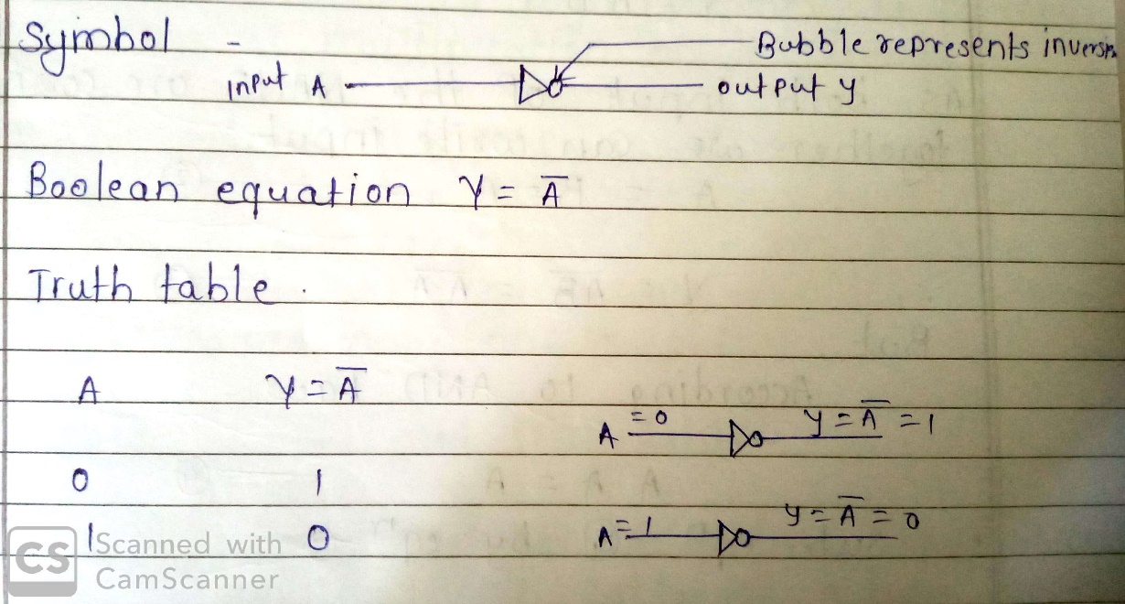

**Expression:-**

Equation of NOT gate using NAND gate:-

Y= -----------1

Also input of NAND gate are connected together we can write input

A=B=A----------2

Y==---------------3

But According to AND low

A.A=A-----------4

Sub.equation 4 by eq 3

Y=

Y=------------5

Which is the eq of NOT gate.

Logic digram:-

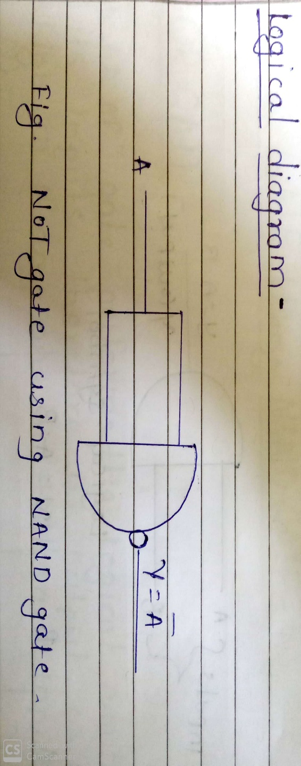

**AND gate using NAND gate :-**

AND gate:- it is one of logic operator. It perform the logical multiplication on it’s inputes.

Logic symbol and truth table:-

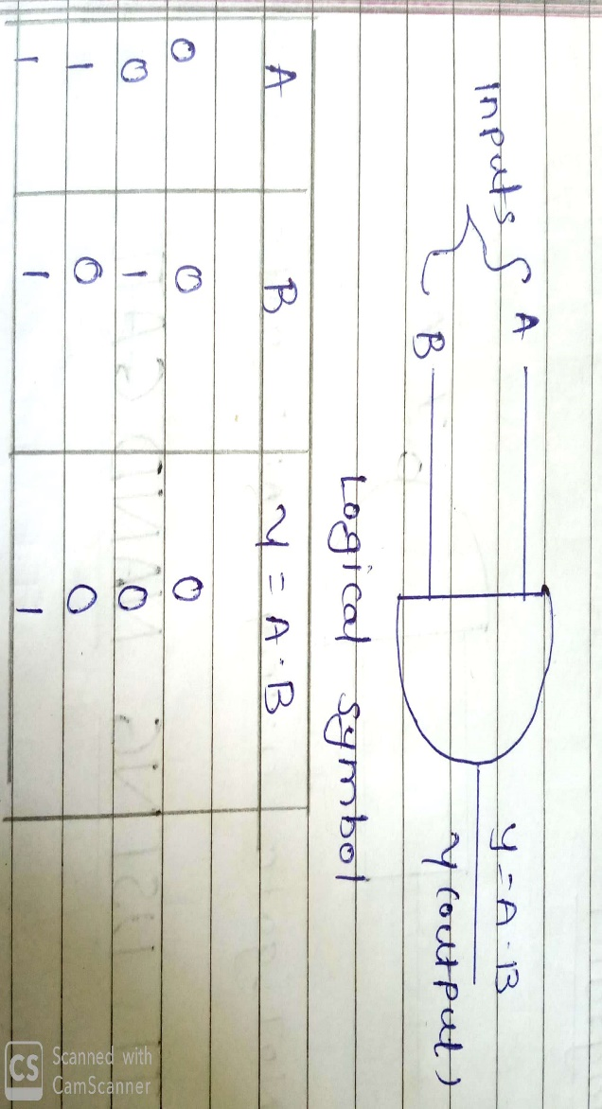

Expression :-

Eq of NAND gate :-

Y=A.B----------------1

Take double inversion of above eq

Y=-----------------2

Y=A.B------------------3

Logic diagram:-

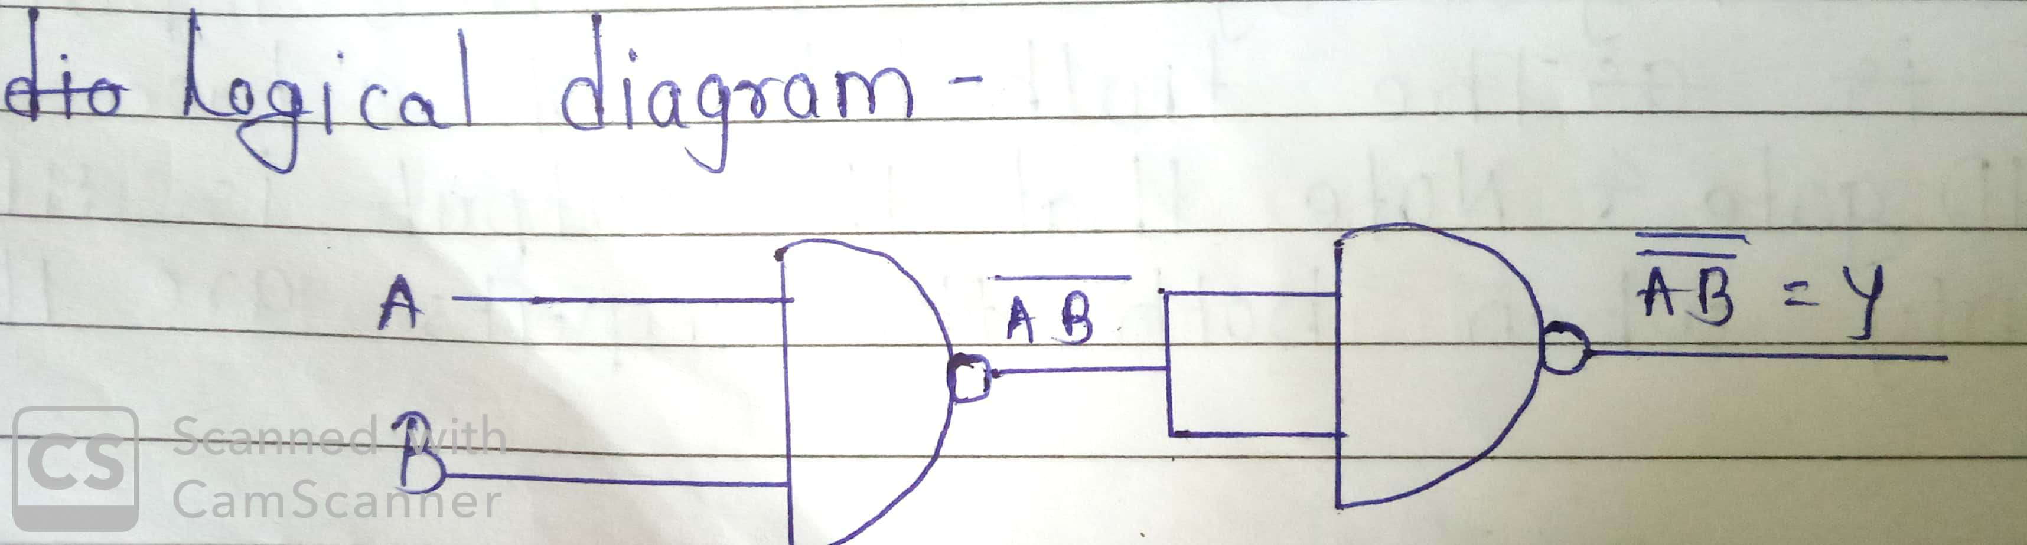

**OR gate using NAND gate:-**

**OR gate :-** OR gate perform logical addition on it’s inputs.

Logical symbol and truth table:-

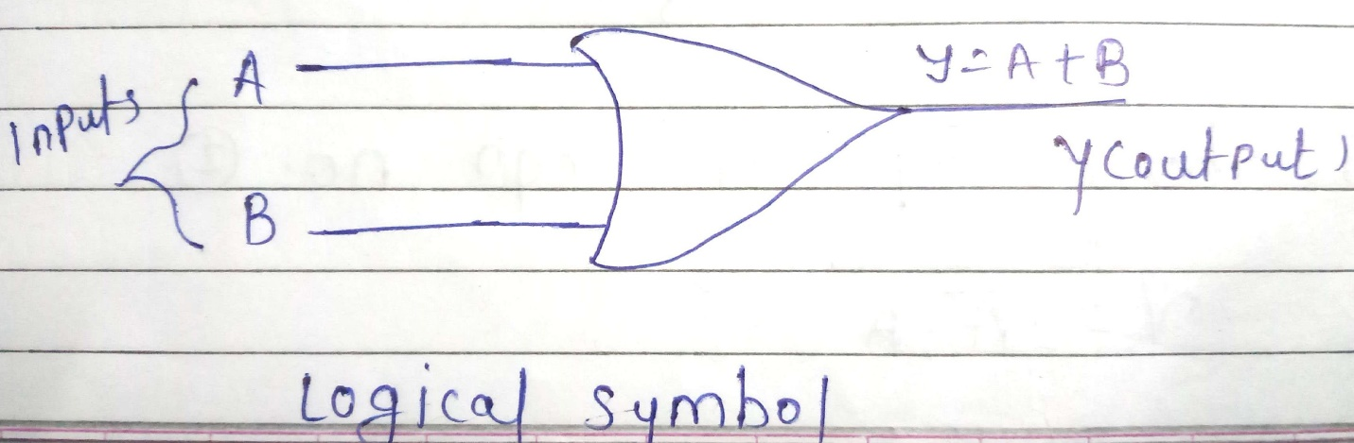

Boolean equation:-

Boolean expression for two input of OR gate is

Y=A+B

Expression :-

Eq of OR 0gate

Y=A+B-------------1

Take double inversion of above eq

Y=----------------2

According demorgan theoram

= .

Sub.above eq in above eq no 2

Y=.

Logic digram:-

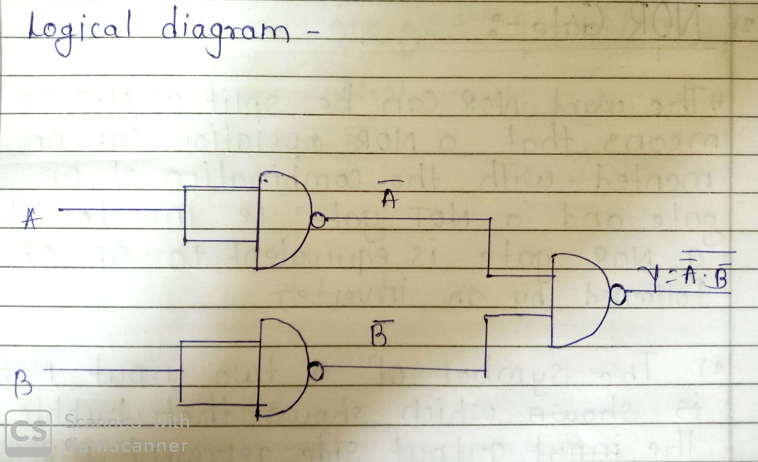

**NOT gate using NOR gate :-**

Expression:-

Eq of NOR gate

Y=--------------------1

Connect both input of NOR gate to each other

A=B=A--------------------2

Rearrange eq no 1

Y=-----------------3

According to Boolean low

A+A=A

Y=

Eq of NOT gate :-

Logical diagram:-

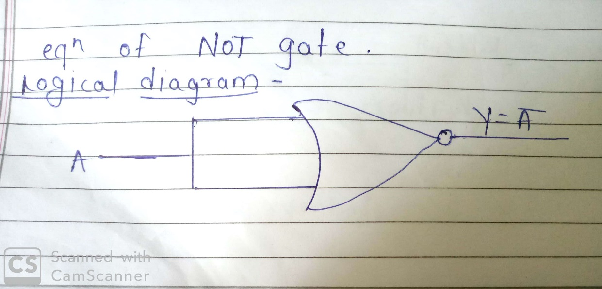

**AND gate using NOR gate:-**

Expression :-

Y=A.B…………………1

Take double inversion of above equation

Y=………………….2

We using demorgan theorem

= +………………..3

Substitute equation 3 in equation 2

Y=+

Equation of AND gate

Logical diagram:-

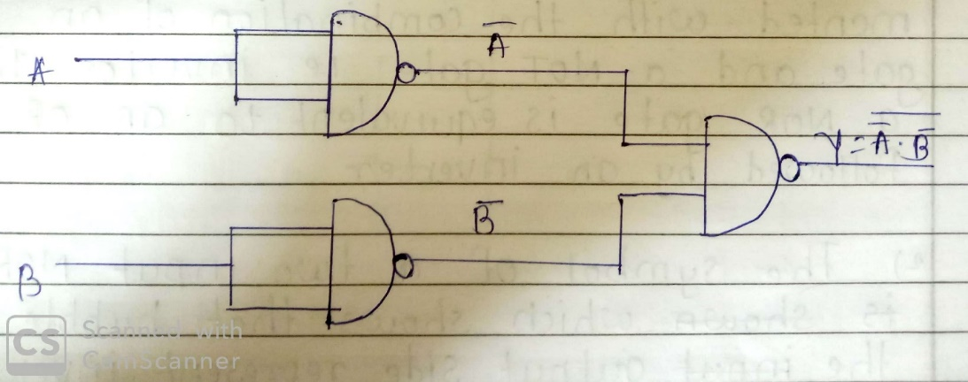

**3)OR gate using NOR gate:-**

Expression :-

Eq if OR gate

Y=A+B…………………1

Take double inversion of above equation

Y=…………………...2

Y=A+B---------------------3

Logical diagram:-

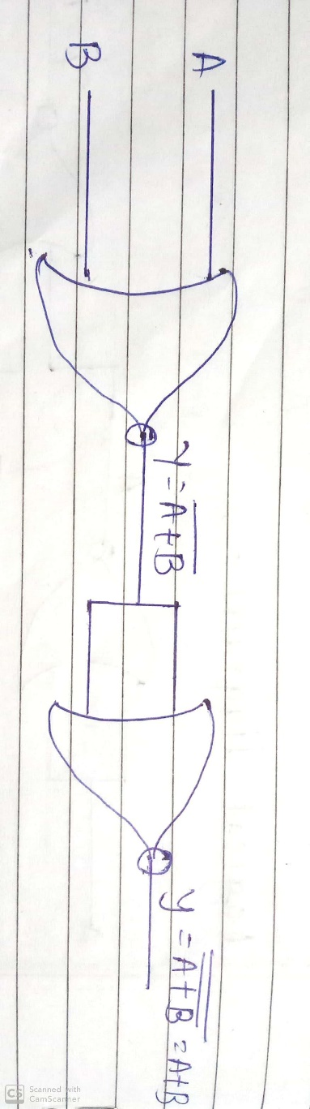

**SKILL DEVELOPED / LEARING OUT OF THIS MICROPROJECT :-**

1. In this microproject we can learn the concept of Basic gate and Universal gate.
2. in this microproject we can learn also two type of universal gate that are NAND & NOR gate and three type of basic gate that are AND , OR & NOT gate.
3. And also learn how to wark as a team member.
4. We can also make blogdigram and truth table.